Test Case: tc001_SPX_Dev5_Crear_Requisicion_Spot_Tipo_Cobro_CC
Step 1 - Enter username and password and click to button Enter : Credentials Entered
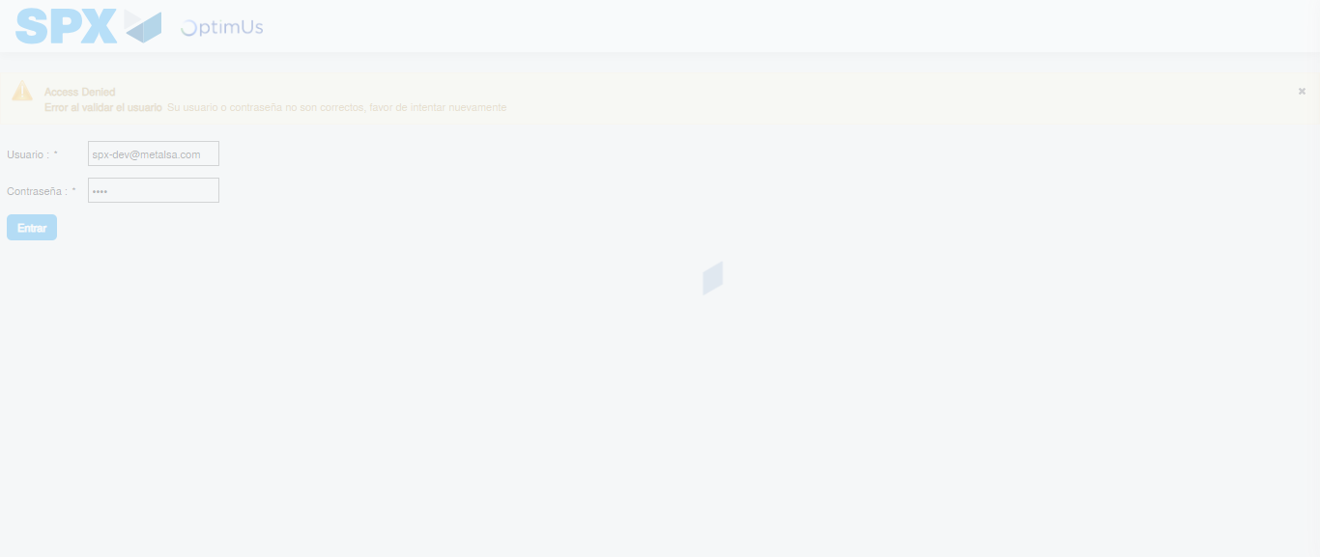Image file-name: QC_Testing-tc001_SPX_Dev5_Crear_Requisicion_Spot_Tipo_Cobro_CC-1784568909916

Step 2 - Select to UEN and Access to Spot Buy Requisitions : UEN Correctly selected and Correct access
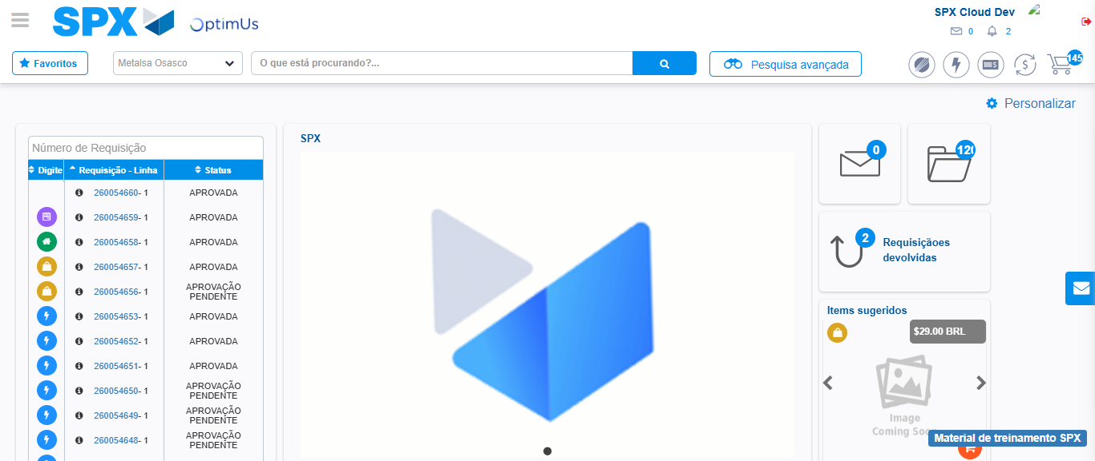Image file-name: QC_Testing-tc001_SPX_Dev5_Crear_Requisicion_Spot_Tipo_Cobro_CC-1784568981799

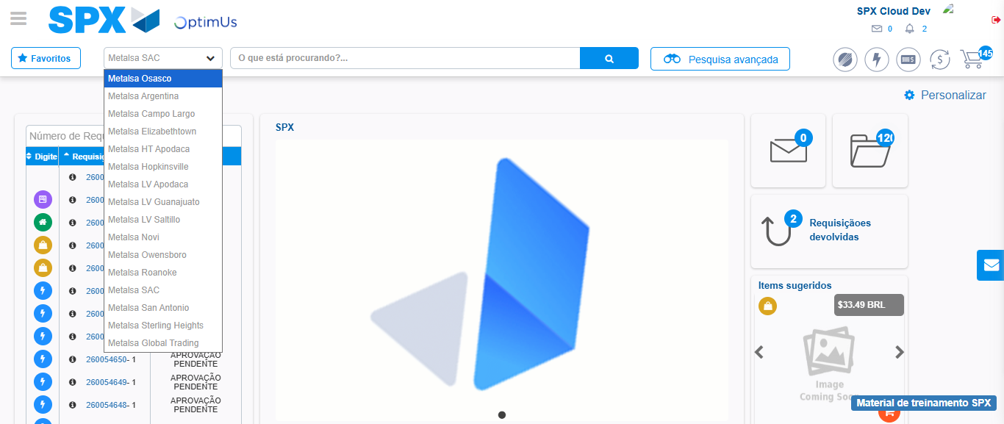Image file-name: QC_Testing-tc001_SPX_Dev5_Crear_Requisicion_Spot_Tipo_Cobro_CC-1784568984640

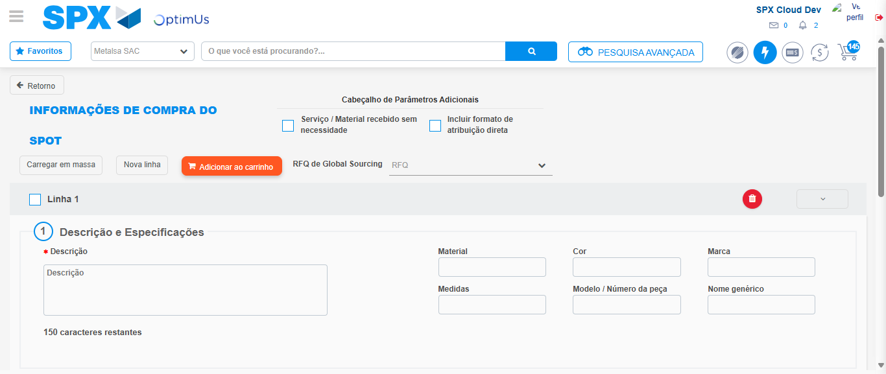Image file-name: QC_Testing-tc001_SPX_Dev5_Crear_Requisicion_Spot_Tipo_Cobro_CC-1784568997867

Step 3 - Data Capture Spot Buy Requisition : Data captured correctly
Image file-name: QC_Testing-tc001_SPX_Dev5_Crear_Requisicion_Spot_Tipo_Cobro_CC-1784568998145

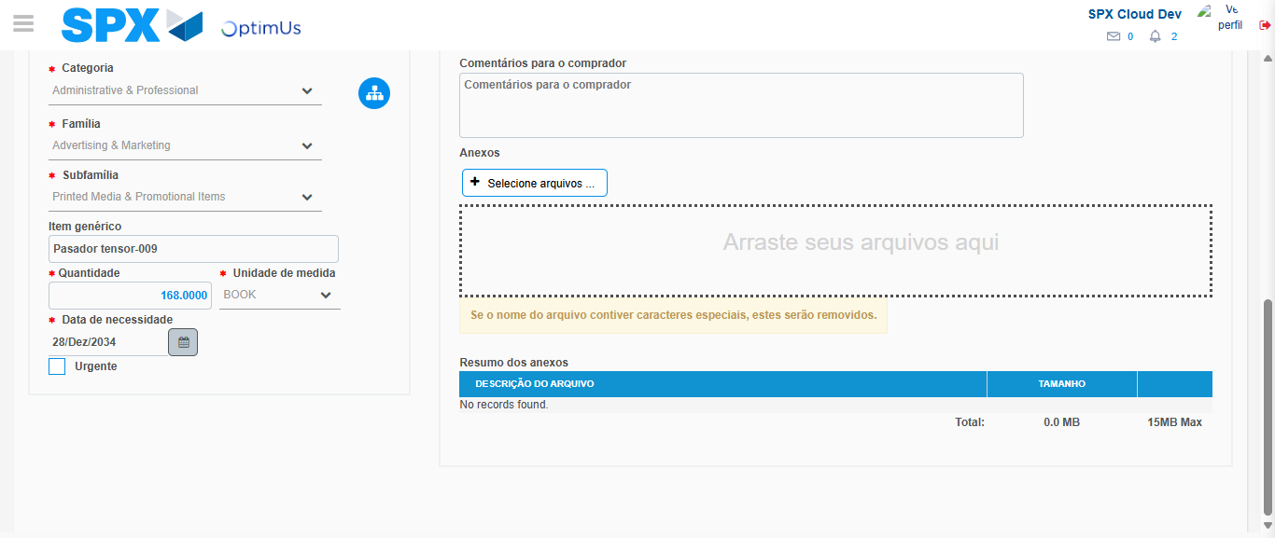Image file-name: QC_Testing-tc001_SPX_Dev5_Crear_Requisicion_Spot_Tipo_Cobro_CC-1784569011320

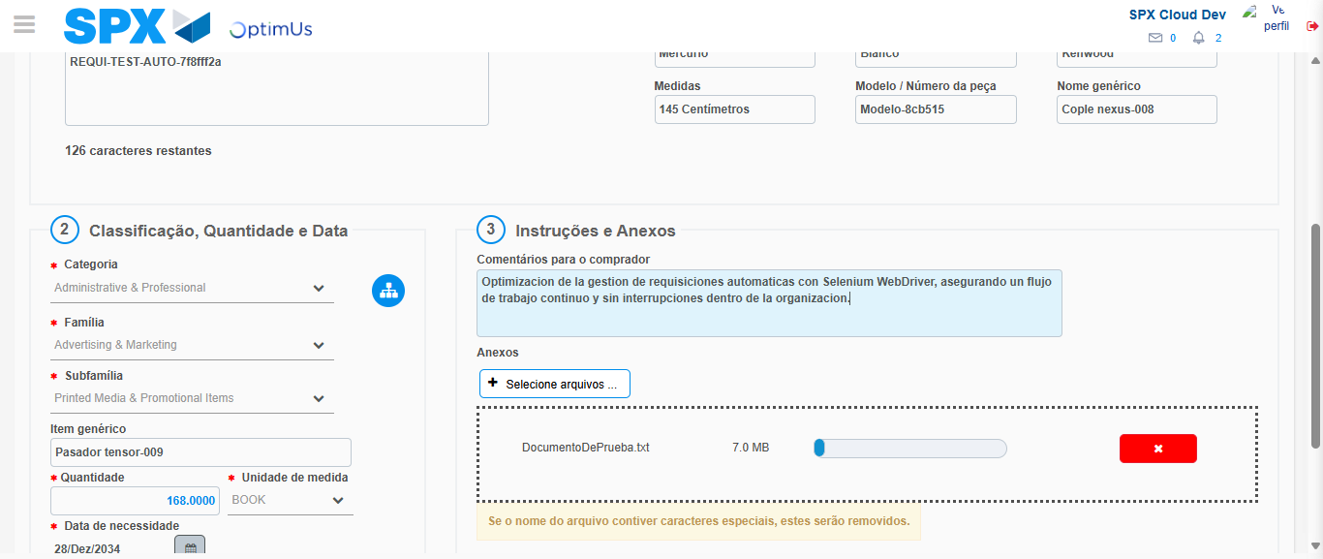Image file-name: QC_Testing-tc001_SPX_Dev5_Crear_Requisicion_Spot_Tipo_Cobro_CC-1784569012267

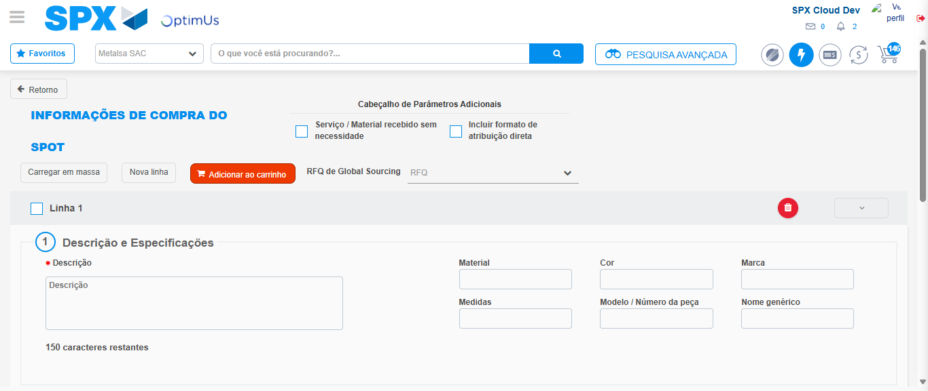Image file-name: QC_Testing-tc001_SPX_Dev5_Crear_Requisicion_Spot_Tipo_Cobro_CC-1784569026629

Step 7 - Return to Main Page SPX : Return to Main Page SPX
Image file-name: QC_Testing-tc001_SPX_Dev5_Crear_Requisicion_Spot_Tipo_Cobro_CC-1784568981799

Image file-name: QC_Testing-tc001_SPX_Dev5_Crear_Requisicion_Spot_Tipo_Cobro_CC-1784568984640

Image file-name: QC_Testing-tc001_SPX_Dev5_Crear_Requisicion_Spot_Tipo_Cobro_CC-1784568997867

Image file-name: QC_Testing-tc001_SPX_Dev5_Crear_Requisicion_Spot_Tipo_Cobro_CC-1784569028891

Image file-name: QC_Testing-tc001_SPX_Dev5_Crear_Requisicion_Spot_Tipo_Cobro_CC-1784569029054

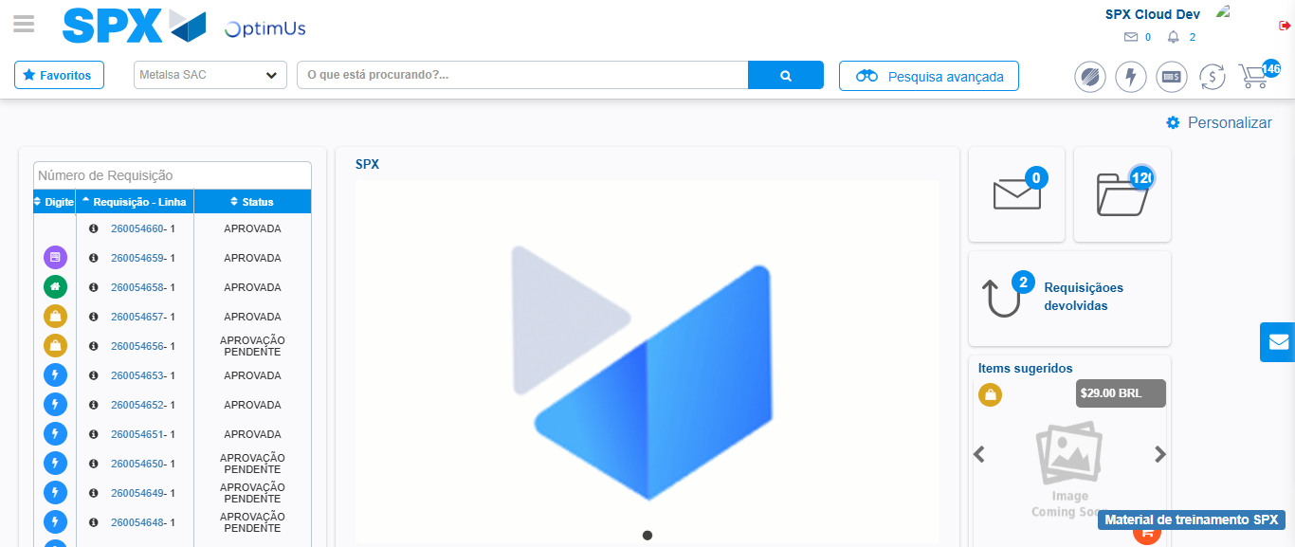Image file-name: QC_Testing-tc001_SPX_Dev5_Crear_Requisicion_Spot_Tipo_Cobro_CC-1784569050216

Step 8 - Log Out : Log Out SPX
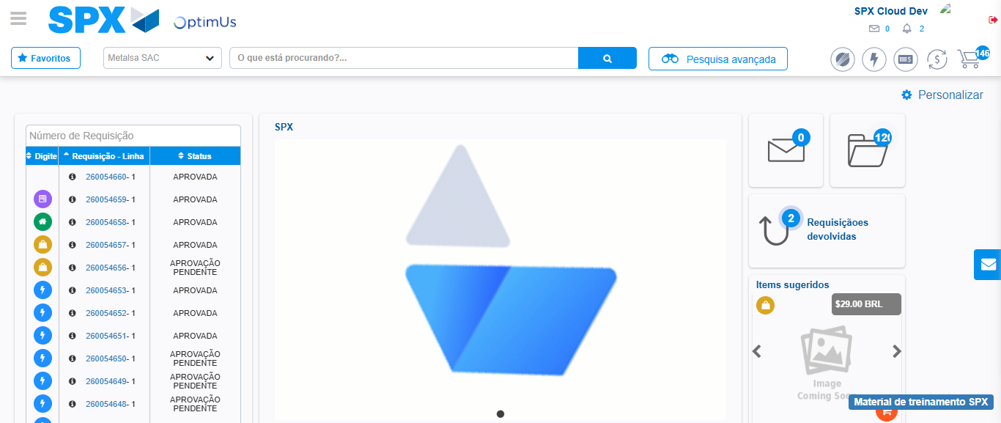Image file-name: QC_Testing-tc001_SPX_Dev5_Crear_Requisicion_Spot_Tipo_Cobro_CC-1784569050551

